**SCMS School of Technology and Management**

**Prathap Nagar, Muttom, Cochin**

|  |  |
| --- | --- |
| **NAME OF THE HOSTING DEPARTMENT** | Department of Management |
| **Name of the Faculty coordinator(s)** | Dr. Deepa Babu K G  Dr. Vilas Nair |
| **Name of the Student coordinator(s)** | Mr. Aadith S Manikandan  Ms. Aleena k Francis |
| **Name of the Event** | Integrated Management Learning Program (IMLP) |
| **Date & Time** | 19-12-2024, THURSDAY |
| **Venue** | SCMS Seminar Hall |
| **Resource Person/ Organization** | SCMS School of Technology and Management |
| **Participants**  **(Inclusive of participants number):** | Students of MBA B22 (115) |
| **Event description** | The program started at 9:15 AM with a prayer. The topic was International Market of Different sectors and was managed by the team Armonia with cooperation  of Mba department faculties. There were total of 4 groups and their topic was energy and power supply, marketing sector, media and entrepreneurship sector, logistics and supply chain. MS Swathi ma’am from PGDM department and Dr Deepa Pillai ma’am from Mba department were the judges for the day. Each group got a time of total 20minuets. There was a warning bell at 18minuets. Both the judges take their time to ask the questions and clear their doubts they were very careful about each and everything including the ppt slides. It was a very interesting section because the students get to know about the various sectors and how the contribute to the world. Each topic was different and have a thoughtful insight All faculties were there in order to support the students. The program ended at 1 PM and the result was announced on that day itself. |

**Pictures:**

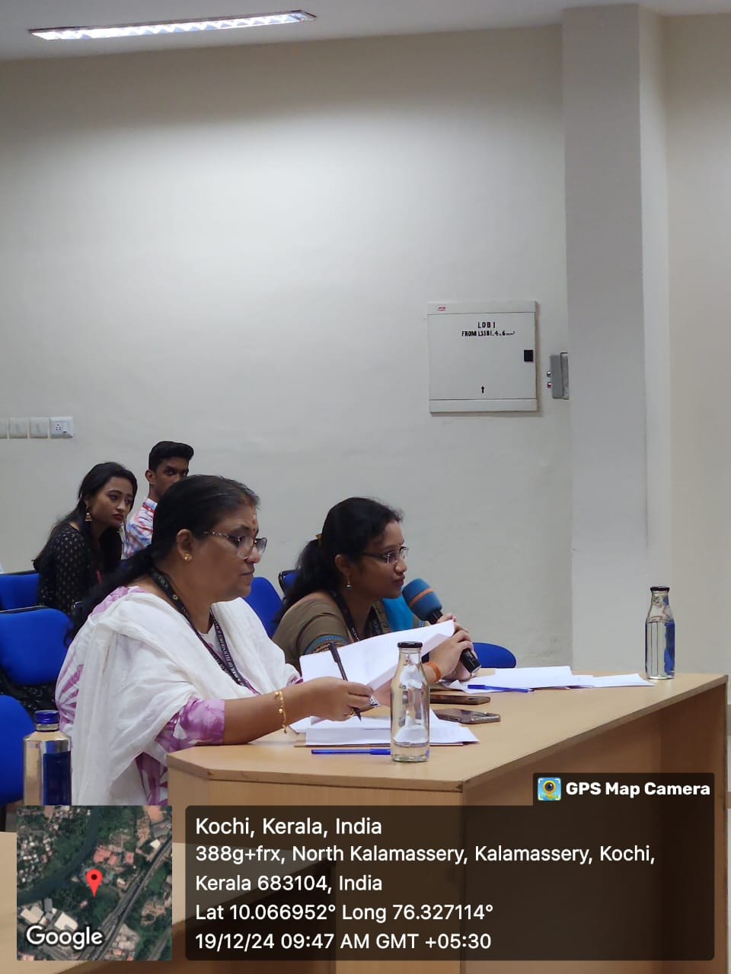

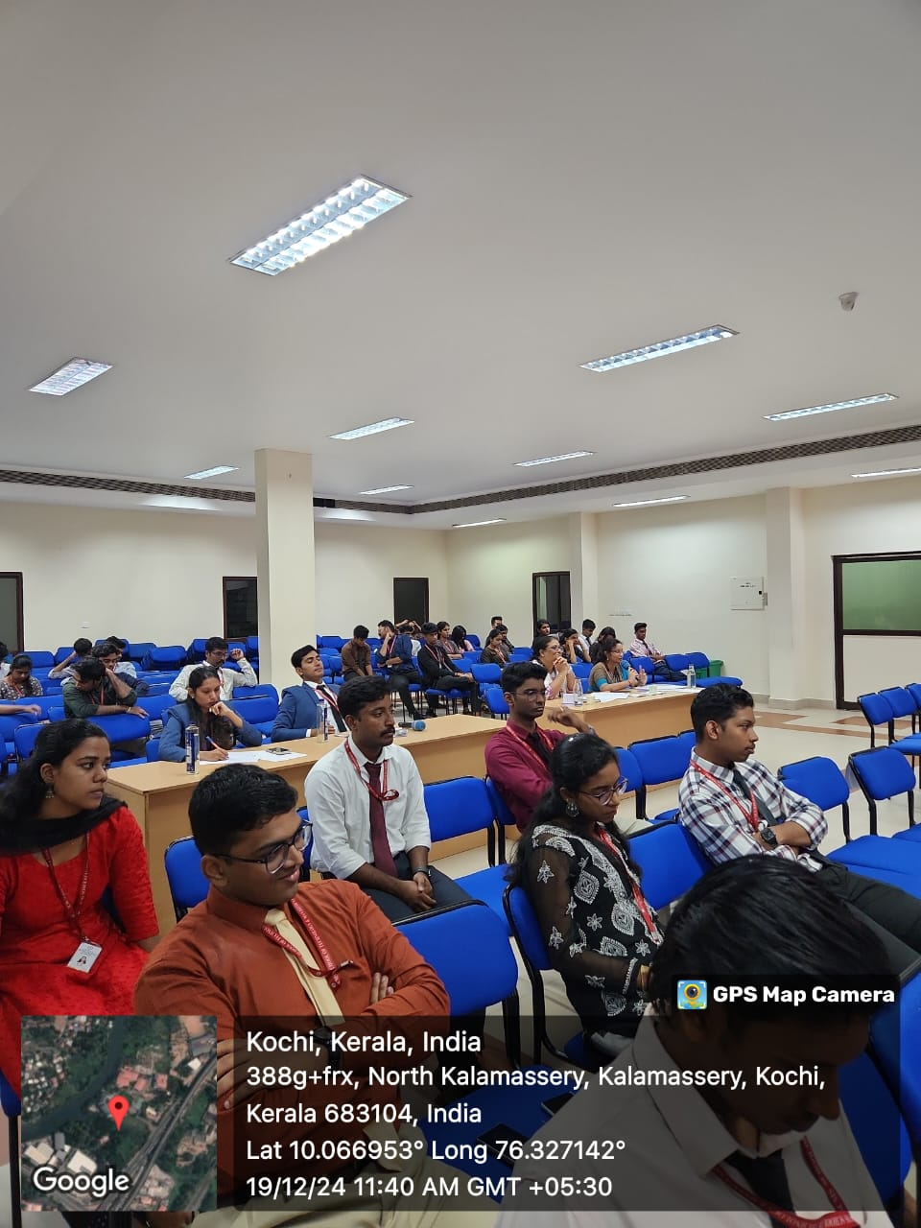

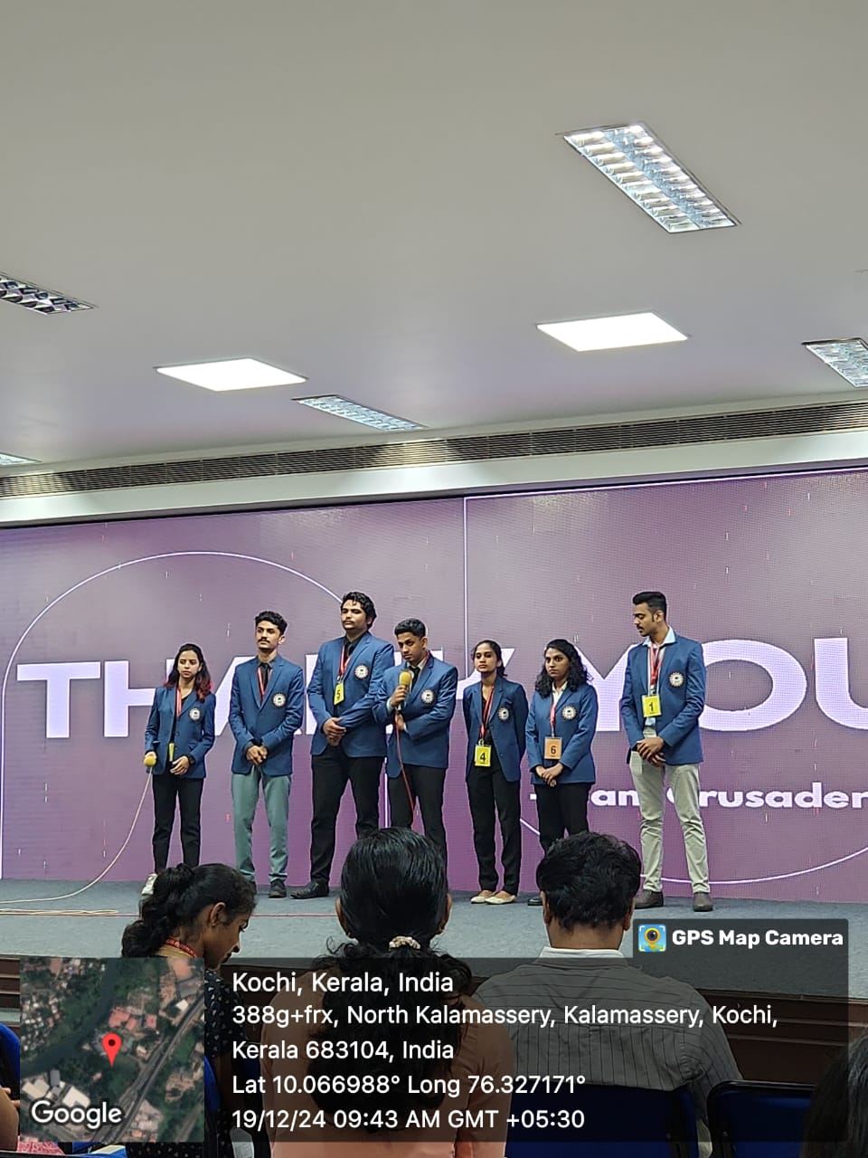

**Signature of the Faculty College Signature of the Principal**

**Event Coordinator Seal**